Program Data 3-3
Accessing the Program Data Screen 3-3
Adding a Program 3-3
Default Lead Times 3-6
Default Freight Cost 3-6
Saving the Data 3-8
Selecting a Program 3-8
Opening and Activating a Program 3-8
Switching between Programs 3-9
Editing Program Data 3-9
Copying a Program 3-10
Closing a Program 3-10

program data
Figure 3-1—Program Data screen 3-3
Figure 3-2—Blank Program Data screen 3-4

Program data

Accessing the Program Data Screen
After you install PipeLine and click on the PipeLine icon, the Program Data screen is displayed.

PipeLine has a sample program database called “Ministry of Global Health,” which shows how PipeLine displays and organizes data. The sample database is displayed on PipeLine’s initial startup (see Figure 3-1).
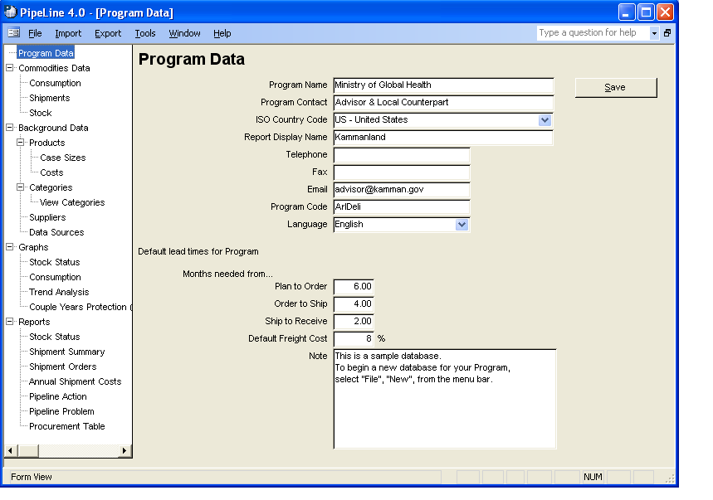
Figure 3-1—Program Data screen

Adding a Program
The File option of the PipeLine Menu Bar enables you to add a program to PipeLine. To add a new program—

- Click on the File Menu Bar option.

- Click on the New option of the File drop-down-menu.

PipeLine displays a blank Program Data screen similar to Figure 3-2.
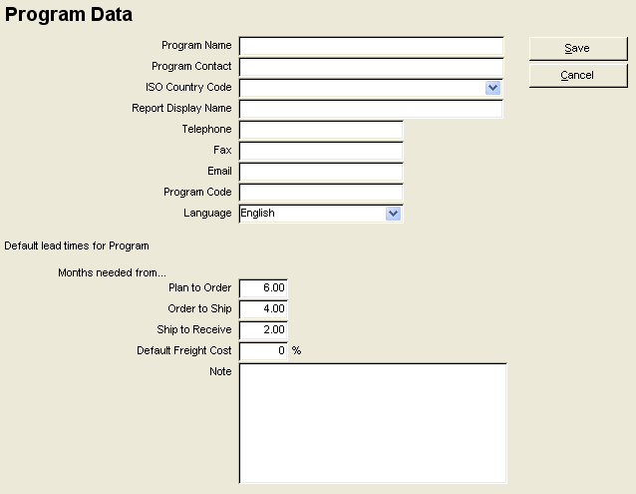
Figure 3-2—Blank Program Data screen

- Click in the Program Name field, and type the new program’s name.
 | The Program Name, ISO Country Code, Report Display Name, and Program Code fields are required. The remaining fields are optional or may retain their default values.

- Click in the Program Contact field, and type the name of the program’s contact person.

- Click on the pull-down menu arrow in the ISO Country Code field. Scroll down to find the country, click on the country to select. The Report Display Name will be automatically filled in.

- Click in the Telephone field, and type the contact person’s telephone number.

- Click in the Fax field, and type the contact person’s fax number.

- Click in the Email field, and type the contact person’s email address.

The Program Code field holds the program’s identification code. This ten-character code must be unique.

- Click in the Program Code field, and type the program’s code.

PipeLine supports English, Spanish, French, Arabic, and Portuguese. The Language field enables you to set the default language for the program you are creating.

PipeLine's default language is English; all PipeLine’s screens and messages are initially displayed in English. To change the default language of the new program—

- Click on the arrow next to the language field and select the program’s default language from the pull-down menu.
 | The selected language is used when the associated program is active. To temporarily change the language of an active program, select Language from the Tools option on the Menu Bar. However, after you exit and restart PipeLine, the system will revert to the program’s selected default language.

Default Lead Times
Program default lead times are used to calculate procurement actions for needed quantities. They are also used for shipments from suppliers without lead times entered and without shipment lead time dates entered.

The Plan to Order field shows the estimated lead time (in months) expected from the time a shipment is planned to when it is ordered. The default is 6.00 (six-month lead time). To change the default—

- Click in the Plan to Order field, delete the default value, and type the lead time.

The Order to Ship field shows the estimated lead time (in months) expected from the time a shipment is ordered to when it is shipped. The default is 4.00 (four-month lead time). To change the default—

- Click in the Order to Ship field, delete the default value, and type the order to ship lead time.

The Ship to Receive field shows the estimated lead time (in months) from the time a shipment is shipped to when it is received by the program. The default is 2.00 (two-month lead time). To change the default—

- Click in the Ship to Receive field, delete the default value, and type the ship to receive lead time.

Default Freight Cost
The Default Freight Cost field shows the approximate freight cost for a shipment as a percentage of the shipment’s product value. Include all costs associated with product delivery (i.e., taxes, clearance fees, etc.). PipeLine uses the default freight cost when calculating freight cost if you do not fill in freight cost estimates for individual suppliers.

- Click in the Default Freight Cost field, and type the default freight cost as a percentage of the shipment’s product value.

The Note field is a memo field for additional information about the program, which you may want to store for future reference.

- Click in the Note field, and type any relevant notes.

Saving the Data
After you complete the Program Data form—

- Click on the Save button.

PipeLine displays the Save Database File window so you can save the current program. PipeLine creates the program's default file name based on the program code.

- Click on the Save button to accept the default file name.
Or, type a new file name and click on the Save button.
 | Never save the data to your A:\ drive.

The Program Data form is redisplayed after the data is saved.

Selecting a Program
PipeLine allows you to deselect the current program and activate another. When the Program Data form is displayed, it displays information about the current (active) program. You can activate another program if additional programs exist, as explained below.
 | The active program is the current program. The program's name is displayed on PipeLine screens, reports, and graphs. Only one program can be active at a time.

Opening and Activating a Program
The Open option in the drop-down menu of the File Menu Bar option enables you to select and open a program, which will make the selected program the current or active program. To open and activate a program—

- Click on the File Menu Bar option.

- Click on the Open option on the drop-down menu.

PipeLine displays a window showing the programs available for activation.

Never open a program from your A:\ drive. Move the data from
the A:\ drive to your hard disk, then use the Open option to select the program.
- Click on the program you need to open, then click on the Open button.

Program information associated with the selected file is displayed on the Program Data screen.

Switching between Programs
Although you can only have one program active at a time, PipeLine “remembers” the previous programs you worked with. The program names are kept in a pull-down menu, allowing you to switch between them.

To switch between programs—

- Click on the Window option of the PipeLine Menu Bar.

- Click on any of the programs listed in the drop-down menu.

Program information associated with the selected program is displayed on the Program Data screen. This program becomes the current or active program.

Editing Program Data
You can edit program data for a selected program at any time. If the program you need to edit is not the current program—

- Select the program you need to edit using one the methods in Selecting a Program beginning on page 8.

After the program you need to edit is displayed on the Program Data screen—

- Highlight each field you need to edit and enter the new data.

- Click on the Save button when you finish.

The data is saved and redisplayed on your screen.

Copying a Program
The Copy option of the File option of the PipeLine Menu Bar allows you to make a copy of the current program. The copy can only be saved to your hard disk. Use this option to archive the data.
 | This feature can also be used to backup your program data.

If the program you need to save is not the current program—

- Select the program you need to copy using one of the methods in Selecting a Program beginning on page 8.

With the current program you need to save displayed on the Program Data screen—

- Click on the File option of the PipeLine Menu bar.

- Click on the Copy option in the File drop-down menu.

PipeLine displays a window so that you can select where the copy will be stored.

Never save the data to your A:\ drive.
- Select the location where you want to store the copy.

- Click on the Open button to save the data to the selected location.

The data is saved.

Closing a Program
Use the Close option of the File Menu Bar option to close any open program.

Closing a program removes it from the open program list. You can reopen any closed program by following the instructions in Opening and Activating a Program on page 8.

To close a program—

- Select the program you want to close.

- Click on the File option of the PipeLine Menu Bar.

- Click on the Close option of the File drop-down menu.

PipeLine displays a message window so you can confirm that you want the selected program closed.

- Click on the Yes button to close the selected program.

